**A PROPOSED OFFERING OF A GYM MANAGEMENT**

**SYSTEM FOR ANYTIME FITNESS GYM**

A Project Proposal Presented to the

Faculty of Datamex College of Saint Adeline, Inc.

In Partial Fulfillment of the Requirements for the

Degree of Bachelor of Science in Information Technology

By:

Revilla, James Andrei N.

**INTRODUCTION**

In this part, it will explain the purpose and importance of developing a Gym Management System for Anytime Fitness, highlighting the problems with current manual processes and how the proposed system can provide efficiency, accuracy, and improved services for both staff and members.

This project aims to create a Gym Management System tailored specifically for Anytime Fitness Gym. The system will simplify and streamline daily gym operations by managing key functions such as membership registration, attendance tracking, equipment management, billing, and reporting—all within one easy-to-use platform. By adopting this digital solution, the gym can reduce manual work, improve accuracy, and provide a smoother experience for both staff and members.

Anytime Fitness Gym currently handles a large amount of important information, including member details, attendance records, trainer schedules, and payment data. Many of these tasks are still done manually or with basic tools like spreadsheets, which can lead to mistakes, delays, and extra work. These inefficiencies may slow down service and frustrate members, while also increasing costs for the gym.

As Anytime Fitness continues to grow, it’s becoming clear that a more efficient and reliable system is needed one that can keep up with the demands of a busy fitness center and scale as the gym expands. This project proposes a Gym Management System that brings all these essential tasks together in a single digital platform, making daily operations faster, smoother, and more accurate. This will help the gym save time, reduce errors, and ultimately provide better service to its members.

**Objectives and Goals**

The primary objective of this project is to create and implement a digital system that makes daily gym operations easier and more effective. The goals outlined below are intended to ensure the system supports both gym staff and members while delivering high-quality service and improved operational performance.

* Create an intuitive interface for both administrative staff and trainers to manage gym operations effectively.
* Implement attendance tracking through member ID input.
* Provide scheduling features for personal training sessions and group fitness classes.
* Integrate billing and simulated payment tracking for streamlined financial management.
* Offer administrative reporting tools for data-driven decision-making.
* Ensure scalability and adaptability for future expansion and feature integration.

**CLIENT INFORMATION**

This section provides an overview of the organization, including its establishment, logo, and essential details such as contact information, location, and business background. It highlights the client’s identity, industry, and core services, giving readers a clear understanding of the company’s profile and operations.

# **Client Establishment and Logo**

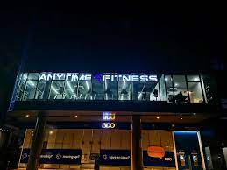



*Figure 1. Client Establishment Image and Logo*

**Client Organization**

* Anytime Fitness Gym

**Contact Information**

Phone: +63 916 778 0078

Address: Col. Bonny Serrano, Skylight Center, 314 Santolan Road, Cor 2nd West Crame, Quezon City, 1504 Metro Manila

**Business and Industry**

Anytime Fitness is a global network of fitness centers operating in over 50 countries and serving millions of members worldwide. Its 24/7 access model provides unmatched flexibility, catering to individuals with busy or non-traditional schedules and meeting the modern demand for convenience and accessibility. A key strength of Anytime Fitness lies in its combination of community and technology. Members enjoy a seamless experience supported by digital tools such as automated membership renewals, online class bookings, and mobile access to training resources.

**PROJECT SCOPE**

This section defines what the project will deliver and the expected outcomes. It outlines the features and functions included in the Gym Management System, ensuring the project stays focused on meeting its primary objectives within the given resources and timeframe.

**Deliverables and Outcomes**

The project will produce a fully functional Gym Management System along with supporting materials to ensure proper usage and demonstration. The expected deliverables and outcomes include:

* Member registration and management
* Attendance tracking using member IDs
* Billing records
* Local deployment of the system for demonstration

**Scope and Delimitations**

This section explains the boundaries of the project by clarifying what is included and what is excluded. It also highlights the assumptions and constraints that guide the system’s development, setting clear expectations for both users and developers.

**Scope**

The Gym Management System is designed to cover the essential functions needed for the efficient management of a gym’s daily operations. It focuses on simplifying membership management, attendance tracking, billing, and administrative reporting while ensuring the system remains secure and easy to use. The following outlines the specific scope of the system:

* Member registration, and managing membership status
* Tracking member attendance using ID input fields
* Simulated billing and payment tracking
* Admin dashboard with reports for attendance, payments, and member status
* User roles for admin, staff, with access restrictions
* Login system with password protection for Admin and Staff
* Secure storage of data using a local database
* System runs on a standalone Windows computer

**Delimitations**

The system is limited to the functionalities defined in its design and development phase, with certain exclusions to keep it simple, secure, and focused on core features. The following are outside the project’s scope:

* The system does not handle real online payments or use third-party payment gateways
* The system does not include biometric or physical attendance devices.
* No mobile application version; the system is for desktop use only.
* The system does not include automated notifications.
* There is no real-time chat or communication feature between members and staff
* No health tracking, or external app integrations.
* Cannot track or verify the honesty or behavior of users.

**Assumptions and Constraints**

To ensure clarity in project planning and execution, certain assumptions are made about the resources, environment, and user capabilities, while recognizing specific constraints that may limit the system’s development and functionality. Identifying these factors early helps guide realistic expectations for the final product.

**Assumptions**

* Users will have basic computer literacy to operate the system.
* The gym will provide a computer with Windows OS compatible with Visual Basic 2010 applications.
* All necessary data for testing and demonstration will be provided in advance.
* Internet connection is not required for core system functions.

**Constraints**

* Development is limited to Visual Basic 2010 and local database storage due to available resources.
* The system will run only on Windows-based machines.
* Timeframe and budget restrictions limit advanced features like online payment integration or mobile app development.
* All functionalities must operate in an offline environment without reliance on external APIs or services.

**PROJECT APPROACH**

The project will adopt the Agile methodology, a flexible and iterative approach that emphasizes collaboration, adaptability, and continuous improvement. Agile is chosen because it allows the development team to work in short, manageable cycles where feedback can be integrated quickly, ensuring the Gym Management System is aligned with client expectations at every stage. Unlike traditional linear models such as Waterfall, which follow a rigid sequence of phases, Agile provides the flexibility to revisit and refine requirements, designs, and features throughout the project.

The goal of this approach is to ensure that the Gym Management System meets the operational needs of Anytime Fitness Gym while being practical, user-friendly, and secure. The project is divided into iterative stages, each focusing on a specific set of deliverables such as member registration, attendance tracking, or billing functions. At the end of each cycle, the system is tested and reviewed to identify potential improvements before moving forward. This incremental progress reduces risks, ensures quality, and promotes active collaboration between the project team and the client.

**Key Activities and Milestones**

1. Define Requirements – Collect and analyze the needs of the client, including features such as member registration, attendance tracking, and billing.
2. Design – Create system architecture, user interface mockups, and database structures to provide a blueprint for development.
3. Development – Begin coding the core system functionalities, starting with essential features, and progressively add more functions in each iteration.
4. Testing – Conduct functionality, security, and usability testing to verify the system works as intended and is user-friendly.
5. Deployment – Install the system on a local machine for demonstration and initial use by the client.
6. Review – Evaluate the system performance and gather feedback from users and stakeholders to identify strengths and areas for improvement.
7. Delivery – Finalize the system with complete documentation, ready for full client handover.
8. Feedback Loop – Use client feedback to refine features and ensure the system continues to align with user needs even after delivery.

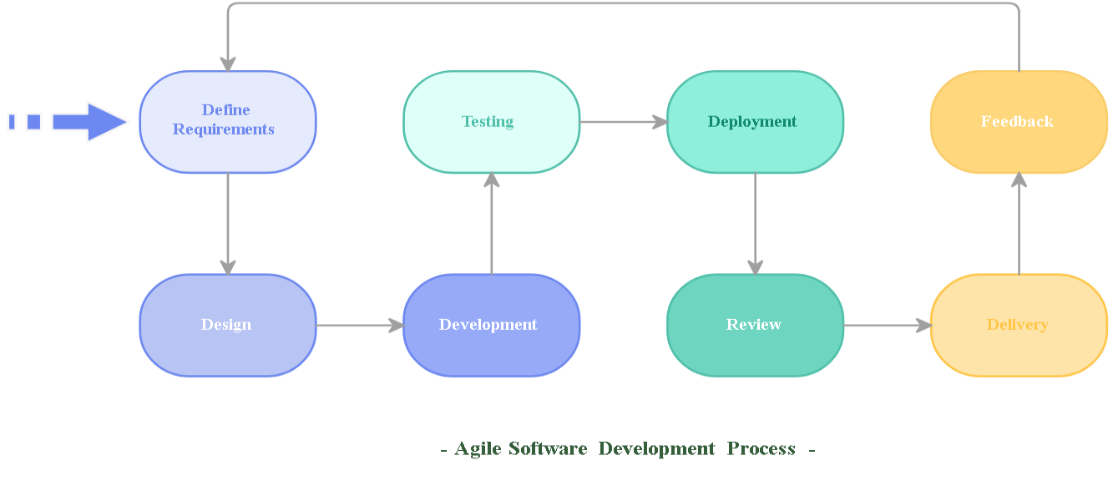

*Figure 2. Agile SDLC*

The figure illustrates the Agile workflow used in this project. It begins with defining requirements and proceeds through design, development, testing, and deployment. Each stage includes review and feedback cycles to ensure continuous improvement. Unlike linear models, this cycle emphasizes adaptability and collaboration, enabling the team to refine the Gym Management System at multiple points before the final delivery.

**PROJECT TIMELINE**

The project is anticipated to be completed within approximately four (4) months, following a phased development cycle aligned with the Agile methodology. Each month corresponds to a sprint-like iteration, with specific modules and deliverables targeted for completion. This structured timeline ensures that core features are developed in parallel with continuous testing and feedback integration, reducing risks and ensuring quality.

|  |  |
| --- | --- |
| **Month** | **Milestone** |
| Month 1 | Requirement gathering, initial design, and development of member management module |
| Month 2 | Development of attendance tracking and scheduling modules |
| Month 3 | Development of billing module, integration, and testing |
| Month 4 | Final testing, deployment, and user training |

*Table 1. Project Timeline*

This timeline leverages the flexibility of Agile development, ensuring that progress is made in small, manageable increments. At the end of each month, partial deliverables are tested and reviewed with the client to gather feedback, which is then integrated into the next phase. By the final month, the system will have undergone multiple rounds of testing and refinement, leading to a stable and user-ready product.

**PROJECT RESOURCES**

This section specifies all the resources required for the successful development, testing, and deployment of the Gym Management System, along with the estimated budget allocation. Windows computer for development and deployment

**Hardware Resources**

* Windows 10 Computer (Development Machine) – Used for coding, database setup, and testing.
* Windows 10 Computer (Deployment & Demonstration) – Dedicated for system installation and client presentation.
* USB Flash Drive / External Hard Drive (32GB minimum) – For system backup and file transfer.
* Miscellaneous Cables/Adapters – For device connections during testing and demo setup.
* Printer – For producing user manuals and documentation.

**Software Resources**

* Microsoft Windows 10 (64-bit) – Operating system for development and deployment machines.
* Microsoft Visual Basic 2010 Express/Professional – Programming IDE used for system development.
* XAMPP (Apache, PHP, MySQL) – Local server for database storage and management.
* Microsoft Office 2016 / Office 365 – For documentation, reporting, and training materials.
* GitHub (Free Version) – For code backup and version control.

**Other Resources**

* Printed and Bound User Manuals – For gym staff reference.
* Training Materials – Slides, handouts, and guides for end-user training.
* Contingency Fund – Reserved for unexpected expenses during development and deployment.

**Budget allocation and justification**

| **Resource / Item** | **Description / Purpose** | **Estimated Cost** | **Justification** |
| --- | --- | --- | --- |
| Visual Basic 2010 IDE | Development environment | ₱0 | Already available, free version used |
| XAMPP (MySQL Database) | Local server for data storage | ₱0 | Open-source, no cost |
| Deployment/Demo Computer (Windows 10, i3, 4GB RAM) | For showcasing final system | ₱20,000 | Dedicated for demonstration and client use |
| USB Flash Drive / External HDD | Backup and system transfer | ₱1,000 | Protects against data loss |
| Printer + Ink | For printing user manuals and reports | ₱5,000 | Needed for documentation and client handouts |
| Printing & Binding | Hard copies of user manuals for staff | ₱500 | Supports staff training and reference |
| Miscellaneous Cables/Adapters | For device connectivity during demo | ₱1,000 | Ensures smooth testing and presentations |
| Training Materials | Slides and references for gym staff | ₱500 | Aids in user onboarding and system adoption |
| Contingency Fund | Unexpected expenses | ₱2,000 | Covers small unplanned costs during development |
| **Total Estimated Budget** |  | **₱30,000** |  |

*Table 2. Budget Allocation*

**RISK MANAGEMENT**

This section identifies the potential risks that may arise during the development and deployment of the Gym Management System. Each risk is assessed by its priority level, with corresponding mitigation strategies to reduce its impact. Proper risk management ensures smoother project execution and minimizes delays or failures.

| **Potential Risk** | **Mitigation Strategies** | **Priority** |
| --- | --- | --- |
| Data loss due to improper saving or unexpected crashes | Perform regular database backups; use version control for code | **High** |
| Resistance to new system from staff unfamiliar with digital tools | Conduct training sessions and provide user manuals | **Medium** |
| Security threats such as unauthorized access to sensitive information | Implement login authentication and password protection; encrypt sensitive data | **High** |
| Delays in development caused by requirement changes or unforeseen bugs | Conduct regular unit testing and integration testing; apply Agile iterations | **Medium** |
| Limited resources in terms of software or hardware for deployment | Prepare documentation for system setup; prioritize core features | **Low** |

*Table 3. Risk Management*